Муниципальное бюджетное общеобразовательное учреждение
средняя общеобразовательная школа имени Героя Советского Союза В.Н. Сластина
сельского поселения «Село Богородское»
Ульчского муниципального района Хабаровского края

Школьная научно-практическая конференция
«Шаг в будущее»

Секция: Филологические дисциплины

“ My Classmates’ Favorite Season”
(Любимое время года моих одноклассников)

Автор: Новикова Ирина,
4 «В» класс, МБОУ СОШ с. Богородское
Руководитель: Пассар Ксения Ивановна,
Учитель английского языка,
МБОУ СОШ с. Богородское

С. Богородское
2023

Аннотация
Тема исследовательской работы“ My Classmates’ Favorite Season” .
Целью работы является: выяснение, какое время года является любимым у большинства учащихся 4 «В» класса.
Объект исследования: времена года
Предмет исследования: любимые времена года учащихся 4 «В» класса МБОУ СОШ с. Богородское
Гипотеза: автор предполагал, что большинство учащихся класса любят лето, потому что летом солнечно и жарко.
В ходе исследования использовались следующие методы:
- Изучение на сайтах информации о погоде в с. Богородское Ульчского района Хабаровского края за 2022 год
- Обобщение и систематизация материала по данной теме,
- Анкетирование учащихся 4В класса МБОУ СОШ с. Богородское, фиксация и анализ его результатов опроса
Автор работы представляет сведения об основных показателях погоды в разное время года в с. Богородское. Также автор исследовательской работы, проанализировав результаты анкетирования учащихся 4 « В» класса пришел к следующим выводам:
- Большинство учеников 4 «в» класса любит зиму, потому что любят играть в снегу.
- Некоторые ученики любят лето, потому что у них день рождения летом, потому что любят, когда жарко и солнечно, многие дети любят купаться летом, кроме того дети любят летние каникулы
- Дети любят весну, потому что погода становится теплее и солнечнее
- Никто из учеников 4»В» класса не любит осень
- Большинство учащихся 4 «В» класса любят читать книги, когда холодно и дождливо
- Когда жарко и солнечно летом, дети любят гулять
- Ученики 4 «В» класса любят играть в снежки, когда холодно и снежно зимой.
- Больше всего дети любят играть в снежки, когда солнечно и тепло зимой.
Результаты исследовательской работы, а также словарь по теме погода можно использовать на уроках английского языка и окружающего мира, календарь дней рождений можно использовать при оформлении классного уголка.

Contents
Introduction
1. Theoretical part 5
Seasons and weather in Bogorodskoye……………………………………………………………4
2. Practical part……………………………………………………………………………………4
2.1. Questionnaire for classmates…………………………………………………………………4
2.2. The results of the research…………………………………………………..………….5
2.3. Making the Birthday Calendar and Weather and Season Vocabulary…………………6
Conclusion………………………………………………………………………………………...6
References 7
Appendix 1 «Questionnaire for classmates» 8
Appendix 2 «The results of questioning (diagrams)» 9
Appendix 3 the Birthday Calendar……………………………..………………………..………11
Appendix 4 Weather and Season Vocabulary .…………………..…………………………12

Introduction

Relevance of the research.
Every English lesson begins with the information about the date and the day of the week , the information about season and weather. Every time the answers of my classmates are different. I wondered what seasons my classmates liked mostly, and why. What is the weather like in my village? What season is our birthday season?
The goal of the research is to get the information what the favorite season of my classmates is.
Tasks of the research:
- to make a Questionnaire about favorite seasons for classmates, their activities in different weather;
- to analyze and organize the information,
- to collect and study the information about the weather in different seasons in Bogorodskoye;
- to make a birthday calendar ;
- to make the weather and season vocabulary
Object of the research: seasons
Subject of the research: my classmates’ favorite seasons
The hypothesis is that favorite season of my classmates is summer, because it is sunny and hot in summer.
Researchmethods:
- search method: searching the on information in the Internet;
- analysis method: selection the most important and interesting information on the topic of research;
- synthesis method: synthesis of the information
Practical significance: materials can be used at English lessons, and Science lessons
Result of the research: birthday calendar, weather and season vocabulary

1. Theoretical part
Seasons and weather in Bogorodskoye
It`s freezing cold and snowy in winter. In 2022 the temperature reached -36, average rainfall 18mm. Sometimes it is sunny and warm in winter; the temperature can be -2 in February.
In spring the weather is different. In March it`s snowy and cold but sunny . The temperature varies from -28 to +5.In April it`s windy and sunny. In May it`s sunny and warm The temperature varies from +4 to +19
In summer it`s sunny and hot. The temperature can be +14 in the morning in June, and as well as +33 in the afternoon in July. July of 2022 was really dry. There were only 4 rainy days in July. Sometimes it’s stormy in summer. Sometimes it`s rainy but warm. The temperature in August is nearly +22. In August it’s often cloudy.
In Autumn it`s weather is different. In September it`s sunny and warm. At the beginning of September the temperature is still about +20. It rarely rains. In the morning it is usually foggy.In October it`s rainy and cold, the temperature drops below 0.In November it begins snowing, the temperature drops below 19.

2. Practical part
2.1. Questionnaire for classmates
Firstly I made a questionnaire for my classmates, where I included questions about their favorite season and the reason, why they liked the seasons (Appendix1). My classmates told me what they do when the weather is good or bad in different seasons. The last question was when their birthdays were.
2.2. The results of the research
According to the results of my research (Appendix 2) the most of my classmates like winter (рис.1), two of them like it because they have birthdays, one person like winter because of the weather, six people like to play in snow (рис.2).
Eight classmates like summer, because two of them have birthdays, one person likes the weather, three people like it because of summer hobbies, two people like it because they have holidays.
Two people like spring because of the weather.
No one likes autumn.
Most of my classmates like to read books when the weather is cold and rainy in autumn. Some of my classmates watch TV (Таблица 1).
Most of my classmates like to go for a walk when it`s hot and sunny in summer.
When it`s cold and snowy in winter my classmates play snowballs, play computer games or go for a walk.
When it`s sunny and warm in winter they play snowballs and go for a walk.
Some of my classmates like summer and winter because they have birthdays then. I call spring birthday season because we have seven birthdays in spring, six ones in summer. In autumn we have only four birthdays, and in winter six birthdays.
2.3. Making the Birthday Calendar and Weather and Season Vocabulary
I made a Birthday Calendar (Appendix 3) for my classroom with funny smiles and a vocabulary. The vocabulary will help me and other student tell the information about the weather and season more accurately.

Conclusion
In conclusion I would like to say that the hypothesis was not proved: the most of my classmates like winter, but not summer.
I have known a lot of new and interesting facts about weather and seasons in our village. I learnt many English words on this topic. I have studied many websites. Moreover, now I know my classmates more. I know what we can do in different weather together and when I should prepare a gift or a card for their birthdays. I am interested in studying English more and more. Next year I am going to continue my research and learn about the most unusual natural phenomena in our region.

References

- GISMETEO https://www.gismeteo.ru/diary/4843/2022/7/
- Ну и погода в Богородском https://bogorodskoe.nuipogoda.ru/
- Reverso, поисковая система переводов вконтекстеhttps://context.reverso.net/перевод/

Appendix 1 «a Questionnaire for classmates»
- What do you usually do when it`s cold and rainy in autumn?
2) What do you usually do when it`s hot and sunny in summer?
3) What do you usually do when it`s cold and snowy in winter?
4) What do you usually do when it`s sunny and warm in winter?
5) What are your favorite seasons? Why?
6) When is your birthday?

Appendix 2 «The results of questioning (diagrams)»

Рисунок 1

Рисунок 2

Таблица 1
 | when it`s cold and rainy in autumn | when it`s hot and sunny in summer | when it`s cold and snowy in winter | when it`s sunny and warm in winter
readbooks | 6 | 0 | 1 | 0
watch TV | 5 | 1 | 0 | 1
surftheInternet | 2 | 2 | 2 | 0
playcomputergames | 3 | 0 | 3 | 1
goforawalk | 1 | 9 | 3 | 5
gofishing | 0 | 2 | 0 | 1
makeasnowman | 0 | 0 | 2 | 3
skate | 0 | 0 | 2 | 1
playsnowballs | 0 | 0 | 4 | 6
goswimming | 0 | 4 | 0 | 0
playsportgames | 2 | 2 | 1 | 1

Appendix 3 the Birthday Calendar
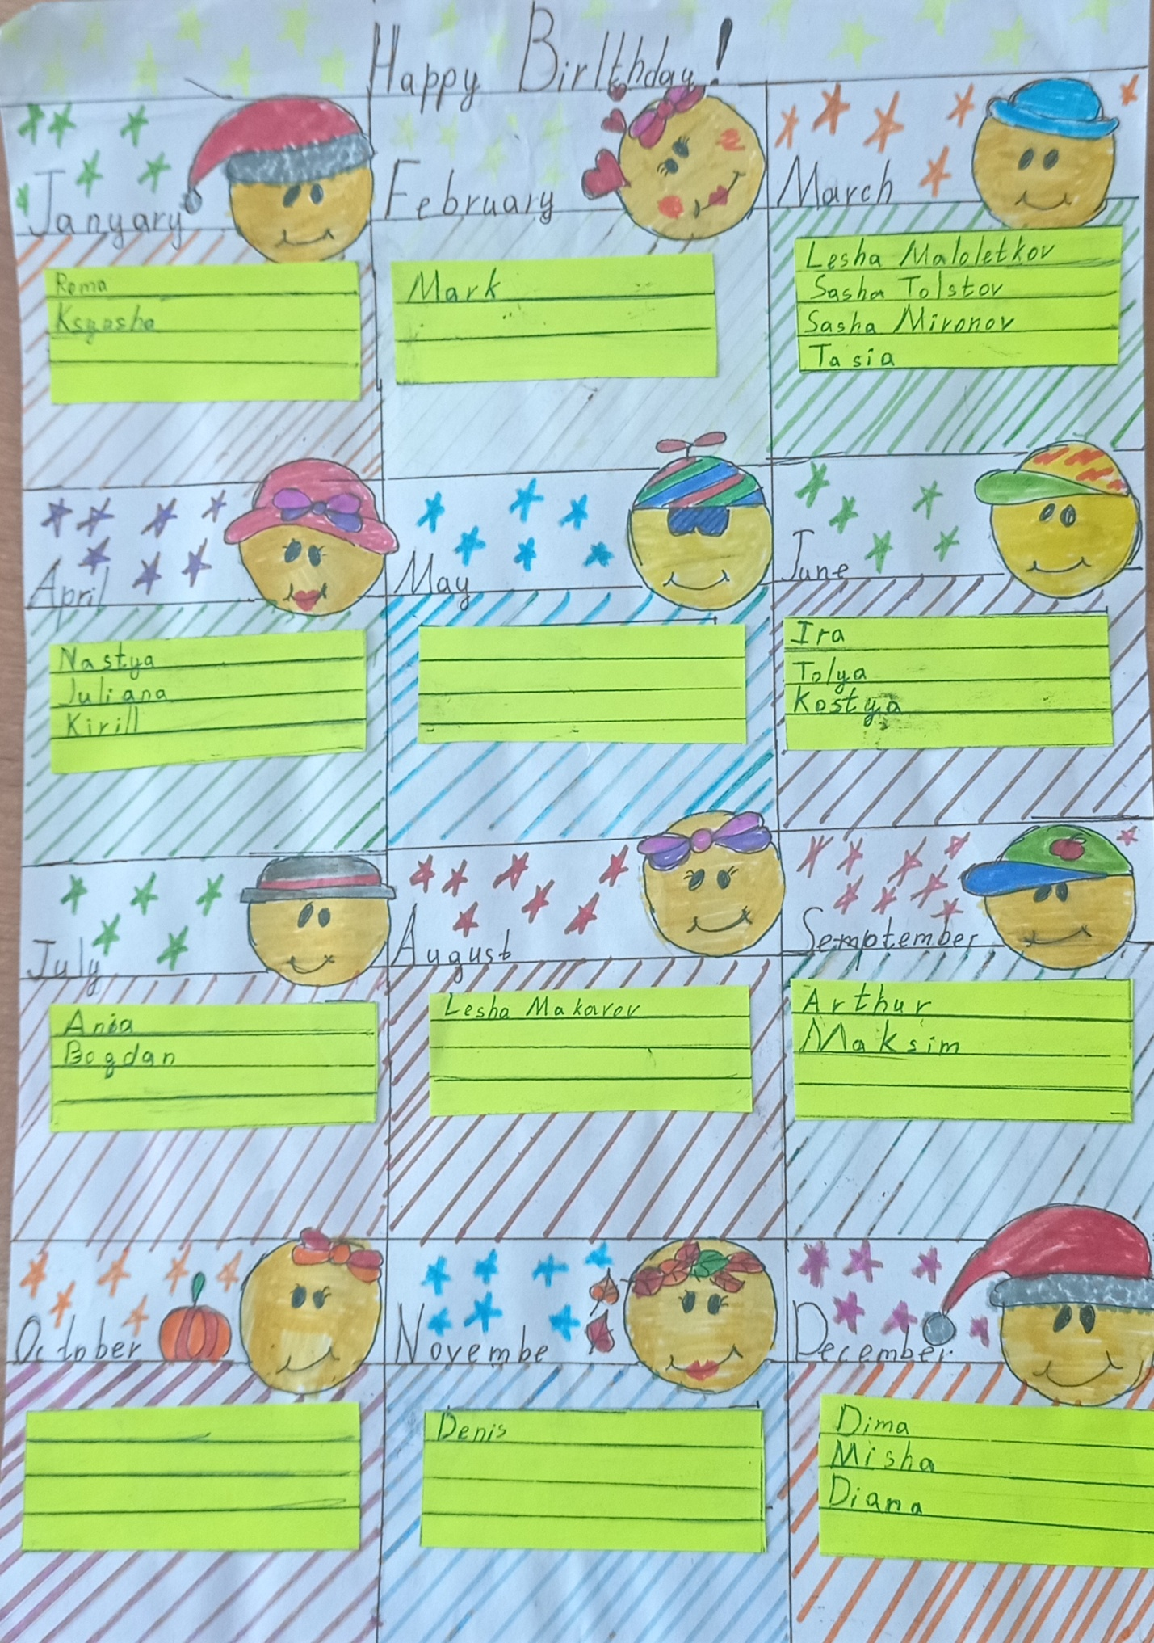

Appendix 4 Weather and Season Vocabulary

